ASSIGNMENT 4

Name: Sankarshan
Roll No: 2301410027
Course: BTech CSE (Cyber Security)

Task 1: Batch Processing Simulation (Python)

Write a Python script to execute multiple .py files sequentially, mimicking batch processing.

CODE

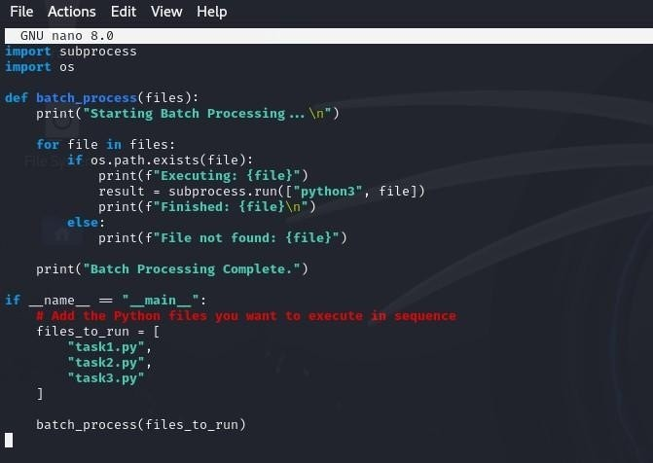

OUTPUT

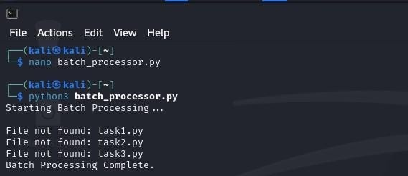

Task 2: System Startup and Logging
Simulate system startup using Python by creating multiple processes and logging their start and end into a log file.

CODE
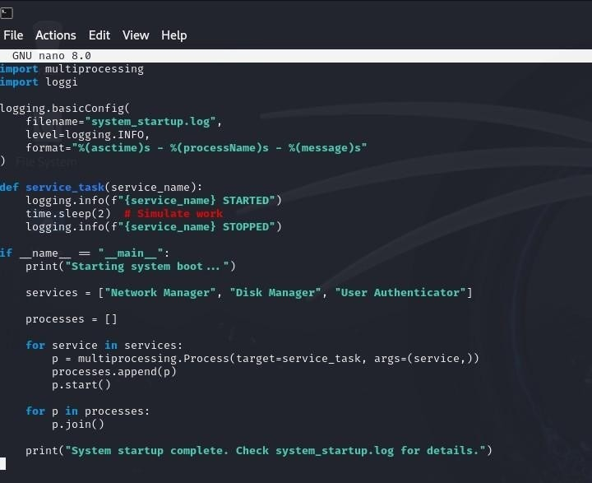
OUTPUT

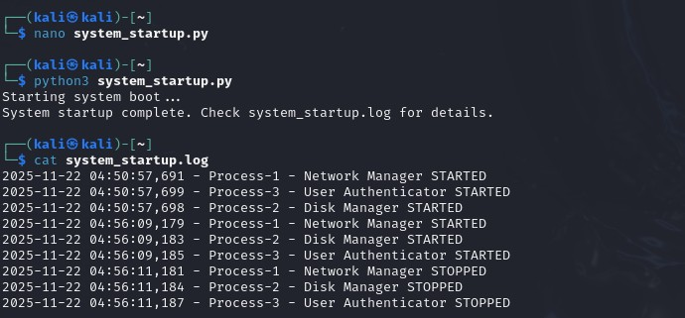

Task 3: System Calls and IPC (Python - fork, exec, pipe)
Use system calls (fork(), exec(), wait()) and implement basic Inter-Process Communication using pipes in C or Python.
• ipc_pipe_fork.py : parent and child communicate via an anonymous pipe (os.pipe + os.fork).

CODE

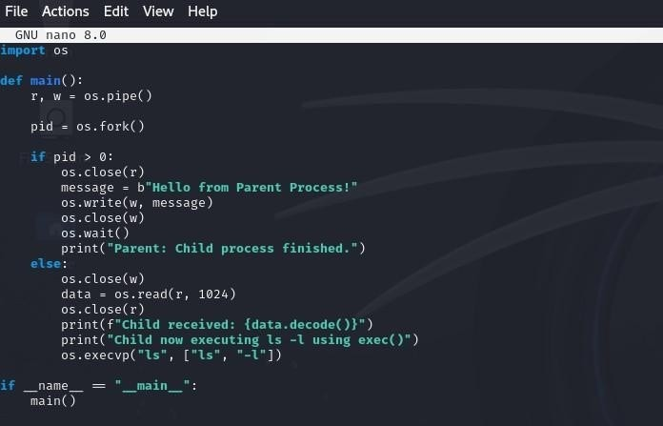
OUTPUT

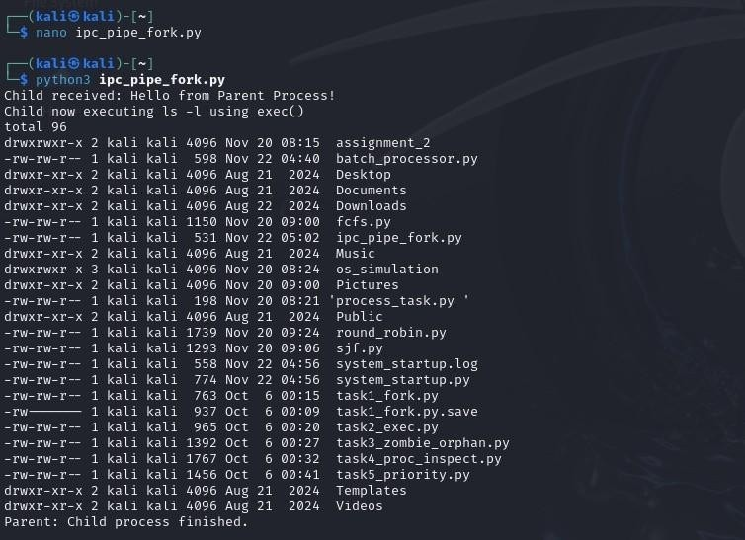
• exec_with_pipe.py: parent creates pipe, forks, child os.execvp() to run grep (or cat) and parent writes into pipe.

CODE

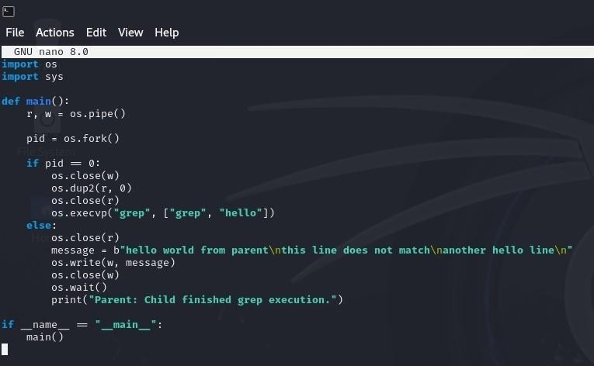

OUTPUT

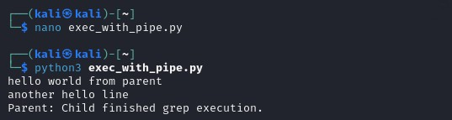

Task 4: VM Detection and Shell Interaction
Create a shell script to print system details and a Python script to detect if the system is running inside a virtual machine.
- Shell script to print system details CODE
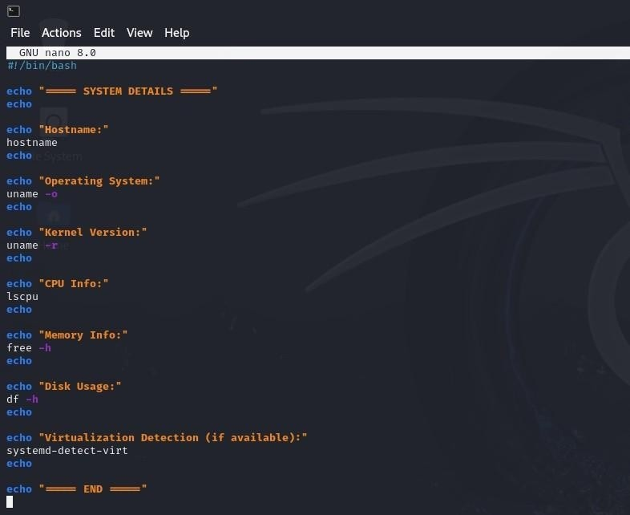
OUTPUT

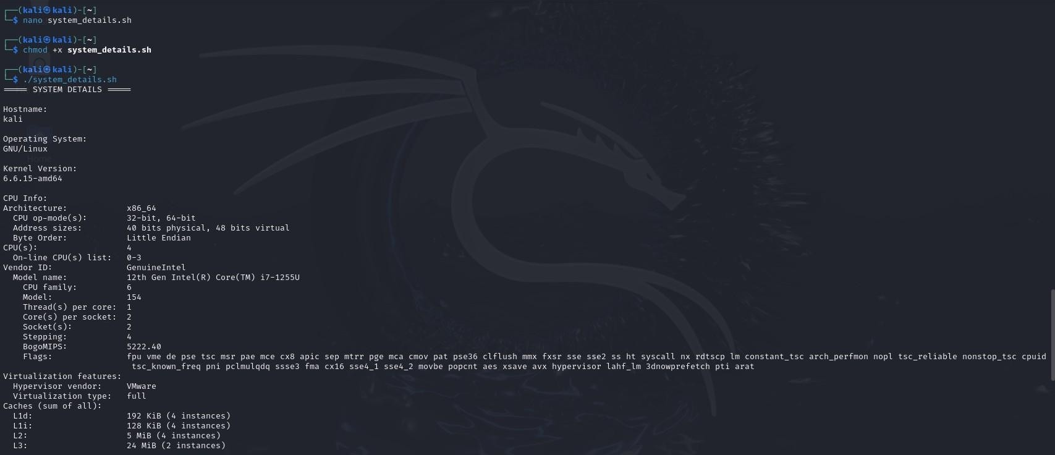

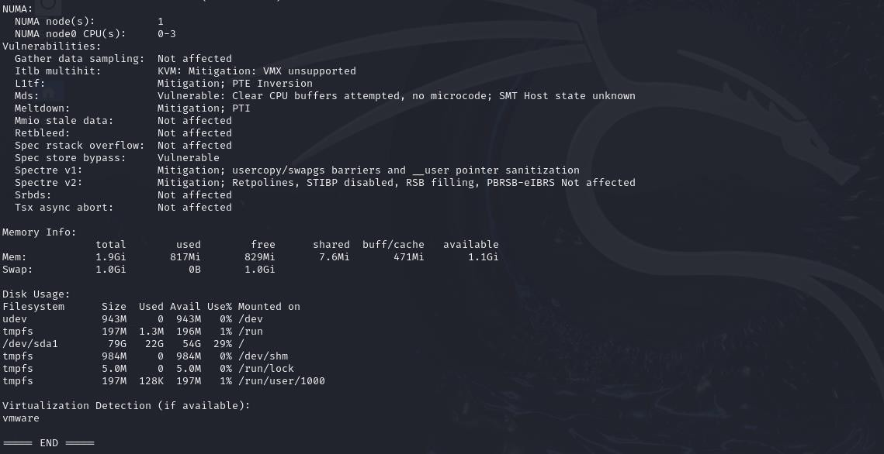
- Python script to detect VM: detect_vm.py
CODE
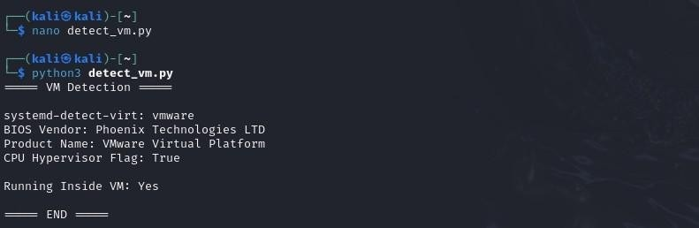
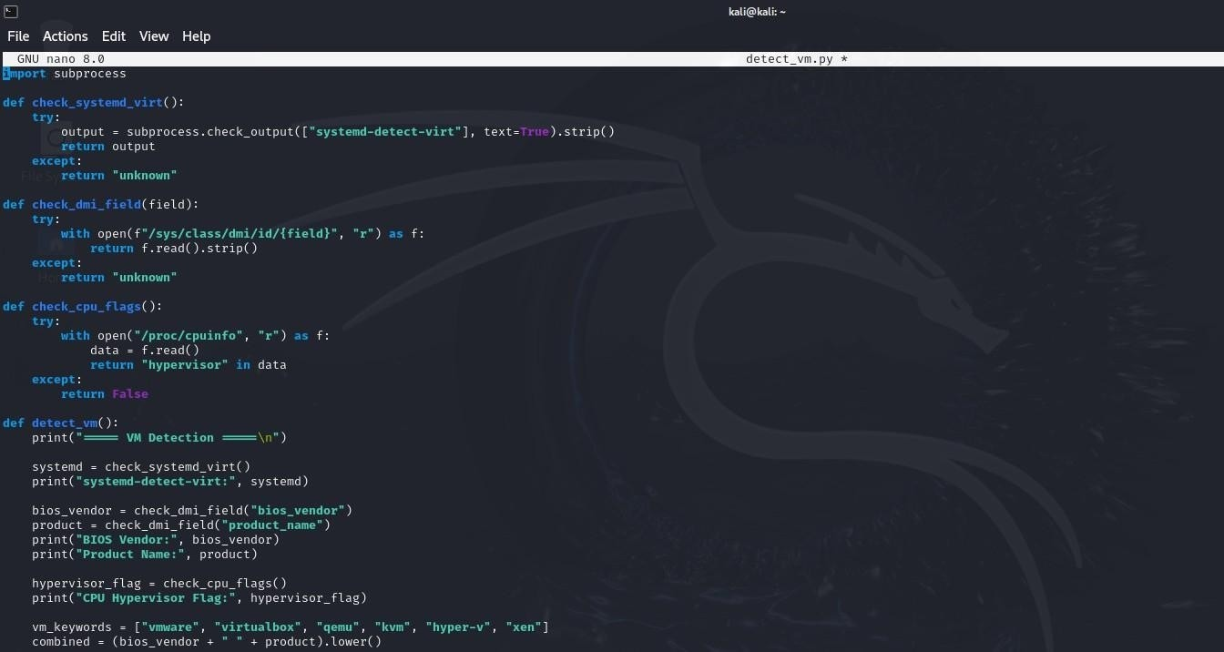

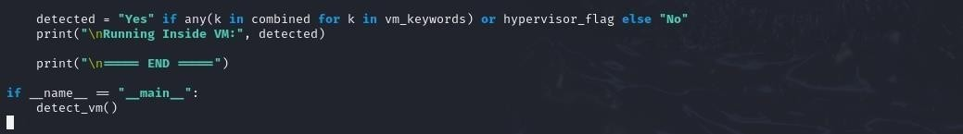
OUTPUT

